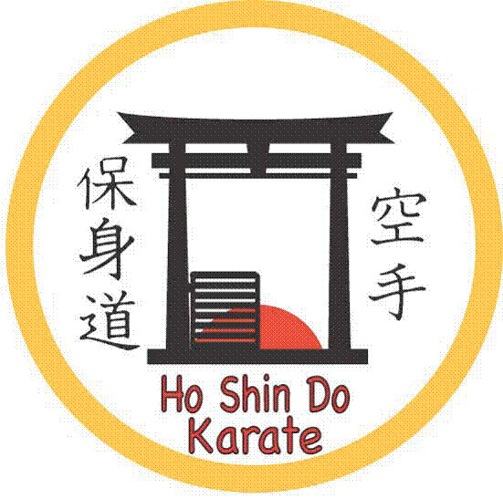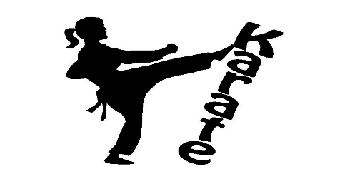

**Brookburn Primary breakfast Karate Club Classes**

Dear Parent /Guardian,

I would like to inform you that the karate classes are being held in School on **Friday mornings from 8.00am – 8.45am.**

**We currently have some spaces available for new starters!**

The classes will start **from the 5th of September 2025 till end of term.**

**What is Karate**?

Karate is a traditional martial art based on self defense and fitness but also

Promotes discipline, confidence, concentration, coordination, self

control, courtesy, respect in general all aspects of character development.

**Kids Club**

The classes will be based on our kid’s club format which is designed to cater for children from 4-12 years of age. It’s is a great fun way to introduce kids to karate in a low key but disciplined environment, the classes are run with emphasis on fun. They learn teamwork, cooperation and get the benefits of self discipline and concentration at the same time. The classes are action packed and the kids love them!!!

**Fees till end of term will cost £75. Fees to be made payable online via Ho Shin Do karate Uk 39083004 sort code 010531.We also provide uniforms at £30 per suit. A grading fee of £20 is applicable for progression to next belt. Please book on ASAP as spaces may be limited. Please use Letters BB and child’s name as reference when making payment.**

To reserve a space or for more information please call Sensei Steve 0n 07708 497 223 or ask for details in the office.

---------------------------------------------------------------------------------------------------

Brookburn primary school Karate Club Classes

Childs Name………………………………………… Parent/Guardian contact no………………

Age …………… Class …………

I give consent for child/children to attend the sessions…………………………………….